Name:M.Hemani

Register no: 192111500

Code:CSA0726

**COMPUTER NETWORKS**

1. IOT Based Smart Home using WPA Security & Radius Server

step1:-first take switch

step2:-link that switch with server and router then connect all with switch like celling fan , door ,lamp and garrage .

step3:-connect that pc with the switch and the switch to router and router to server

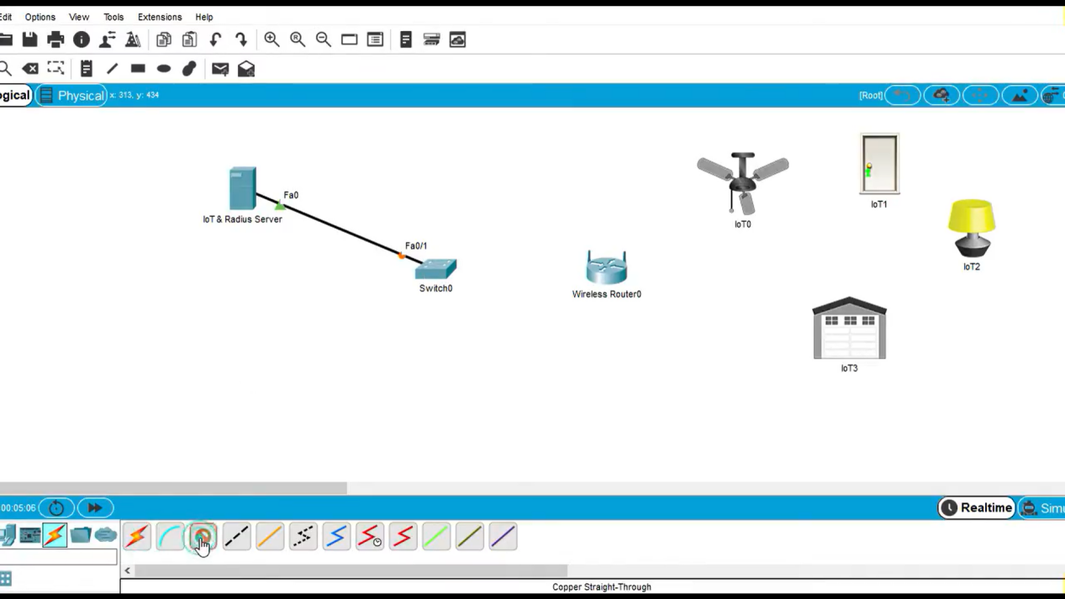

step4:- after connection check the IP address of the all pc in the config

step5:- if command send correctly you got successfull other wise recheck the connections

Step6:- IOT Based Smart Home using WPA Security & Radius Server was simulated in packet tracer .

